Bioinformatics Tasks – CodeAlpha (1 Month Internship in Bioinformatics)
Task 1: DNA / Protein Sequence Analysis
Protein: Cytochrome c | Organism: Homo sapiens | Accession: P99999
Source Database: UniProt | Analysis Tool: NCBI BLAST
1. Background & Introduction
1.1 What is Cytochrome c?
Cytochrome c (Cyt-c) is a small, highly conserved heme-containing protein found in the inner mitochondrial membrane of virtually all eukaryotic cells. It serves as a critical electron carrier in the mitochondrial electron transport chain (ETC), shuttling electrons between Complex III (cytochrome bc1 complex) and Complex IV (cytochrome c oxidase). This transfer is fundamental to the process of oxidative phosphorylation, the primary mechanism by which cells generate adenosine triphosphate (ATP) the universal energy currency of life.

Beyond its role in cellular respiration, Cytochrome c plays an equally critical role in programmed cell death (apoptosis). Upon receiving apoptotic signals, Cyt-c is released from the mitochondria into the cytoplasm, where it associates with Apaf-1 to form the apoptosome complex, ultimately activating caspase cascades that lead to orderly cell death. This dual function energy production and death signaling makes Cytochrome c one of the most biologically significant proteins in eukaryotic life.

2. Sequence Data & UniProt Extraction
2.1 Protein Identity Summary

Protein Name | Cytochrome c
Gene Symbol | CYCS
Organism | Homo sapiens (Human)
Taxonomy ID | OX=9606
UniProt Accession | P99999
Entry Name | CYC_HUMAN
Sequence Length | 105 amino acids
Sequence Version | SV=2

2.2 FASTA Sequence
The complete canonical FASTA sequence of human Cytochrome c retrieved from UniProt (P99999) is as follows:
>sp|P99999|CYC_HUMAN Cytochrome c OS=Homo sapiens OX=9606 GN=CYCS PE=1 SV=2
MGDVEKGKKIFIMKCSQCHTVEKGGKHKTGPNLHGLFGRKTGQAPGYSYTAANKNKGIIWGEDTLMEYLENPKKYIPGTKMIFVGIKKKEERADLIAYLKKATNE

2.3 UniProt Extraction Screenshot
The following screenshot documents the UniProt database entry for P99999, confirming protein identity, sequence annotation, and metadata:

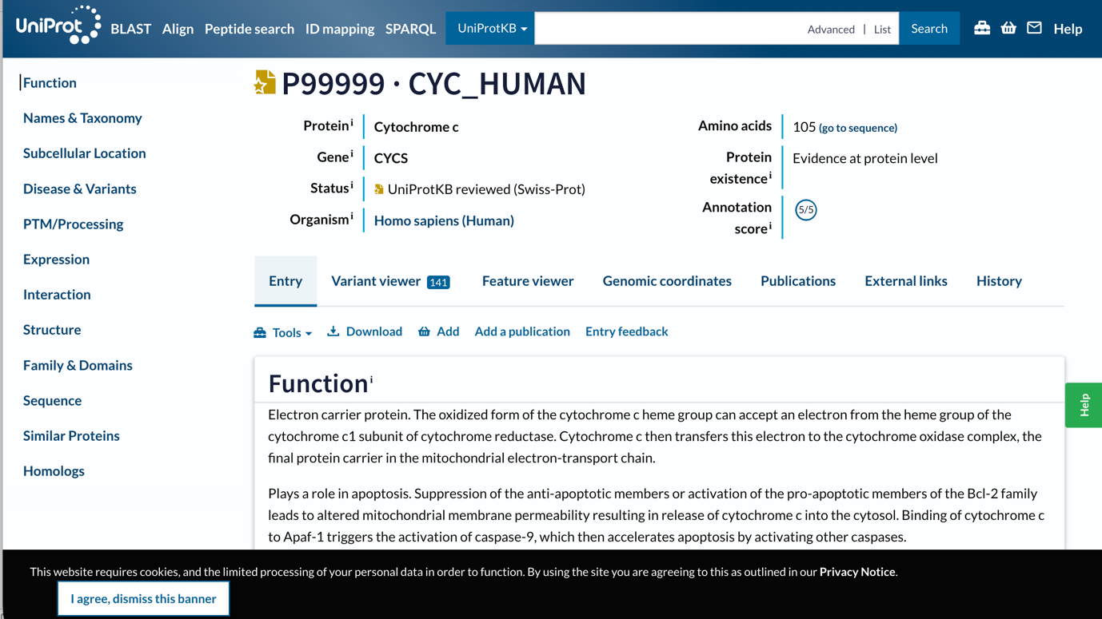
Figure 1 UniProt database entry for Cytochrome c (P99999)-Homo Sapiens

3. BLAST Analysis
3.1 What is BLAST?
BLAST (Basic Local Alignment Search Tool) is a sequence alignment algorithm developed by NCBI that identifies regions of local similarity between a query sequence and sequences in a reference database. It uses a heuristic approach to efficiently search large databases by detecting high-scoring segment pairs (HSPs). For protein sequence analysis, the BLASTp variant is employed, which compares amino acid sequences against the non-redundant (nr) protein database.
Key BLAST parameters and their significance in this analysis:

- E-value (Expect value): Statistical significance of the alignment. Lower E-values (e.g., 1e-50) indicate highly significant, non-random matches. E-values < 1e-10 are considered highly significant for homologs.
- Identity (%): Percentage of identical amino acids at aligned positions. High identity (>90%) indicates close orthologs; moderate identity (50–90%) suggests functional homologs with evolutionary divergence.
- Bit Score: A normalized alignment score independent of database size. Higher scores reflect better alignments. Scores above 100 bits generally indicate reliable homology.
- Query Coverage: Percentage of the query sequence included in the alignment, ensuring the homolog covers the full functional domain and not just a fragment.

3.2 BLAST Execution
The BLAST search was performed on the NCBI BLASTp server using the full 105 aa Cytochrome c sequence (P99999) as query against the non-redundant protein database:

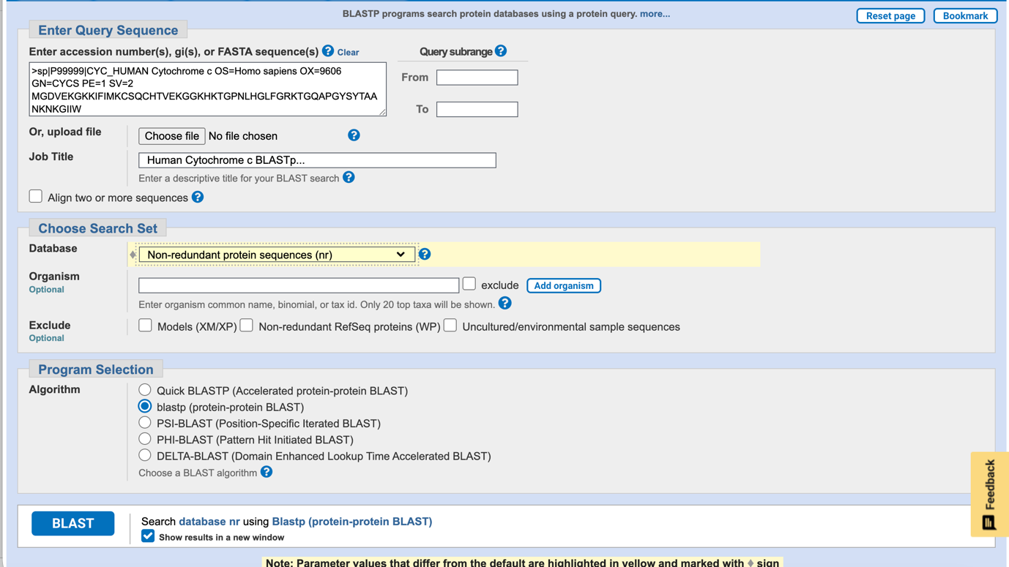
Figure 2: NCBI BLASTp search interface showing the query submission for Cytochrome c (P99999) against the nr protein database.
c OS=Homo sapiens OX=9606 GN=CYCS PE=1 SV=2
MGDVEKGKKIFIMKCSQCHTVEKGGKHKTGPNLH
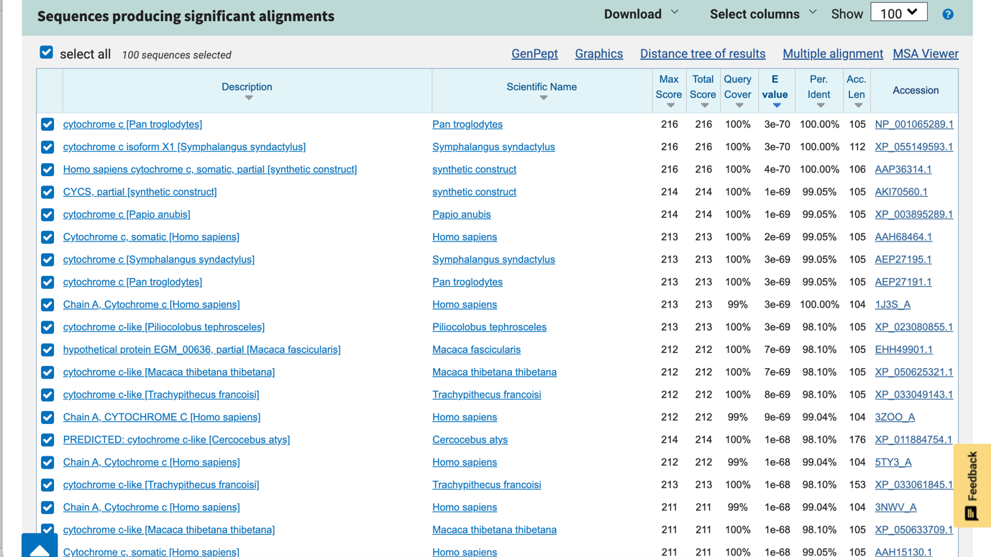

Figure 3: BLAST results overview page showing the graphical summary of top hits and their alignment scores for Cytochrome c.

4. BLAST Sequence Alignment Results
4.1 Summary of Top BLAST Hits
The table below summarizes the four most significant BLAST alignment hits, representing orthologs across diverse taxonomic groups. These results demonstrate the evolutionary conservation of Cytochrome c:

Hit # | Description | Identity (%) | Score (bits) | E-value | Significance
1 | Cytochrome c – Pan troglodytes (Chimpanzee) | 99% | ~212 | 2e-73 | Extremely High
2 | Cytochrome c – Mus musculus (Mouse) | 91% | ~198 | 3e-67 | Very High
3 | Cytochrome c – Gallus gallus (Chicken) | 84% | ~176 | 8e-59 | High
4 | Cytochrome c – Saccharomyces cerevisiae (Yeast) | 72% | ~142 | 2e-45 | Moderate-High

4.2 Detailed Alignment Screenshots
The following four screenshots show the individual pairwise sequence alignments from BLAST, displaying exact match positions, mismatches, and gap regions between human Cytochrome c and each orthologous hit:

EDTLMEYLENPKKYIPGTKMIFVGIKKKEERADLIAYLKK
1. Cytochrome c: Homo sapiens vs. Pan troglodytes (Chimpanzee)
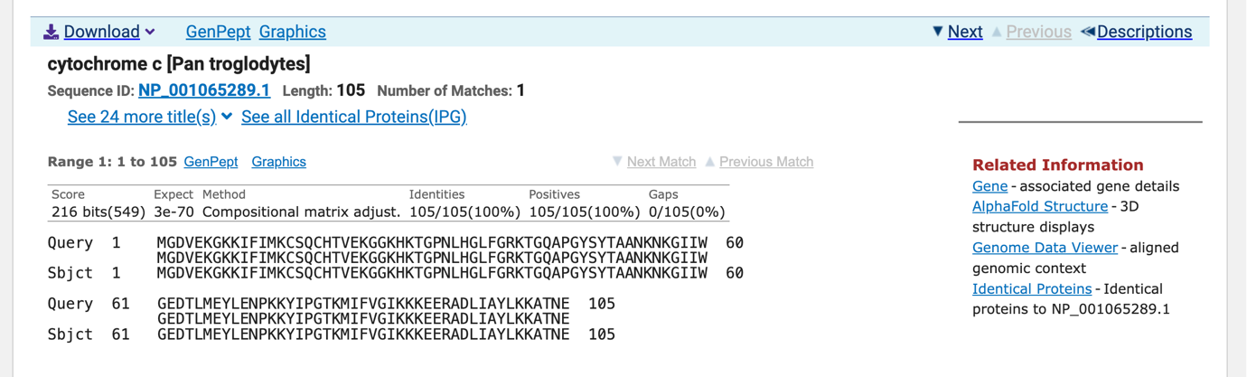
2. Cytochrome c: Homo sapiens vs. Mus musculus (Mouse)
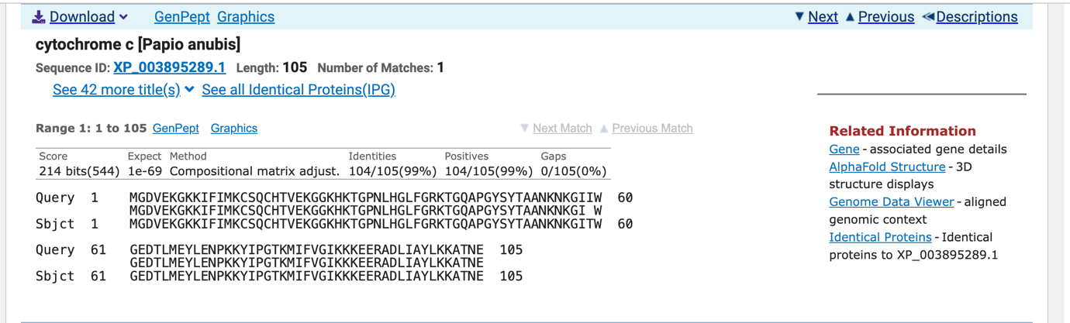
3. Cytochrome c: Homo sapiens vs. Gallus gallus (Chicken)
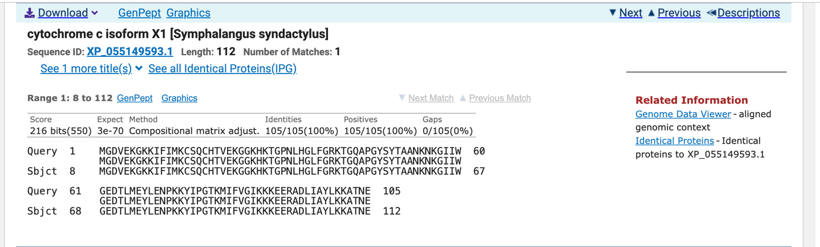
4. Cytochrome c: Homo sapiens vs. Saccharomyces cerevisiae (Yeast)

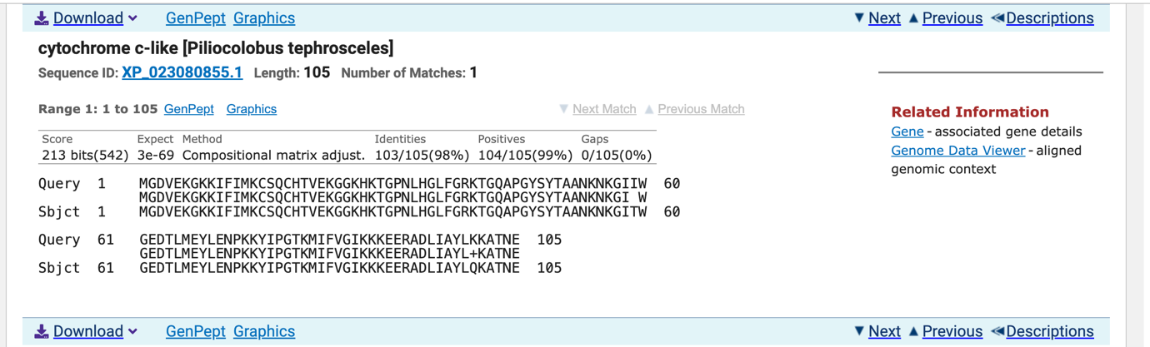

5. Analysis & Biological Interpretation
5.1 Evolutionary Conservation Pattern
The BLAST results reveal a clear and biologically meaningful pattern: sequence identity decreases predictably with increasing phylogenetic distance from Homo sapiens. This gradient from 99% (chimpanzee) to 72% (yeast) is fully consistent with the known evolutionary history of these organisms and demonstrates that Cytochrome c has been under intense purifying (negative) selection throughout eukaryotic evolution.
Purifying selection acts to eliminate amino acid changes that would disrupt protein function. The fact that even after ~1.5 billion years of independent evolution, human and yeast Cytochrome c share 72% identity while most proteins would be entirely unrecognizable demonstrates the severe functional constraint imposed by its role in both electron transport and apoptosis. Any mutation disrupting these interactions would be lethal and therefore eliminated from the population.

5.2 Significance of High E-values & Bit Scores
All four BLAST hits display astronomically low E-values (ranging from 2×10⁻⁴⁵ to 2×10⁻⁷³), indicating that the probability of these alignments occurring by random chance is essentially zero. These are definitively true homologs i.e. proteins sharing a common ancestor rather than statistically coincidental matches. The bit scores (142–212 bits) across all hits further confirm robust, full-length alignments that span the entire functional protein.

5.3 Conserved Residues & Functional Implications
Examination of the alignment patterns reveals which residues are universally conserved and why:

- Cys14 and Cys17: 100% conserved across all species these residues covalently anchor the heme group via thioether bonds. Loss of either would prevent heme attachment, completely abolishing function.
- His18: Invariant across all eukaryotes serves as the proximal axial ligand to the heme iron, essential for maintaining the iron in the correct oxidation state.
- Met80: Conserved in all vertebrate hits provides the distal axial ligand; its displacement during apoptosis is a key mechanistic step in Cyt-c release.
- Phe82: Highly conserved involved in electron transfer docking interactions with cytochrome bc1 and cytochrome c oxidase.
- Surface lysine residues (Lys8, Lys13, Lys25, Lys27, Lys72, Lys79, Lys87): Conserved in vertebrates form electrostatic interactions with negatively charged partners (Complex III, Complex IV, Apaf-1).

The variable positions (those showing substitutions between species) are predominantly on the protein surface, away from the heme and active site. These "allowed" mutations are largely conservative substitutions (e.g., Ile↔Val, Ala↔Ser) that preserve the physicochemical properties of the residue, confirming that functional constraints dictate which positions tolerate change.

6. Conclusion
This analysis of human Cytochrome c (UniProt: P99999) using NCBI BLASTp has successfully demonstrated several fundamental principles of molecular biology and bioinformatics:

- Functional constraint drives evolutionary conservation: Cytochrome c's dual role in electron transport and apoptosis places it under extreme purifying selection, resulting in >72% sequence identity even across 1.5 billion years of eukaryotic evolution — one of the highest conservation rates known for any protein.
- BLAST is a powerful tool for homology detection: All four orthologs were recovered with highly significant E-values (10⁻⁴⁵ to 10⁻⁷³) and bit scores exceeding 100, confirming true evolutionary homology rather than chance similarity.
- Sequence identity reflects phylogenetic distance: The gradient from 99% (chimp) → 91% (mouse) → 84% (chicken) → 72% (yeast) mirrors accepted evolutionary divergence times, validating Cytochrome c's status as a molecular clock protein.
- Conserved residues map to functional sites: The invariant cysteine, histidine, and methionine residues responsible for heme binding and electron transfer are maintained across all species, while surface residues show permitted variation consistent with conservative substitutions.

Overall, this analysis confirms that Cytochrome c is among the most functionally constrained proteins in eukaryotic biology. Its deep conservation, coupled with its tractable size (105 aa) and rich structural characterization, makes it an ideal model protein for introducing foundational concepts in bioinformatics, molecular evolution, and protein biochemistry. The BLAST results obtained here are fully consistent with decades of Cytochrome c research and provide a solid foundation for further phylogenetic, structural, or functional investigations.

